MEMBERSHIP APPLICATION FORM

STICK
PHOTO
HERE
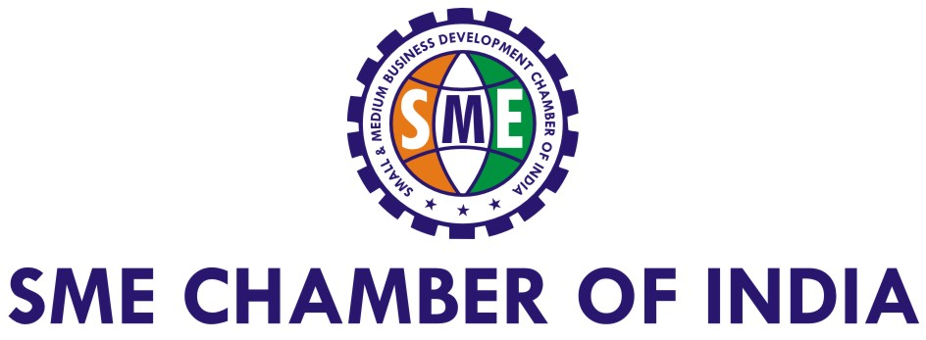
- - - - - - - - - - - - - - - - - - - - - - - - - - - - - - - - - - - - - - - - - - - - - - - - - - - - - - - - - - - - - - - - - - - - - - - - - - - - - - - - - - - - - - - - - - - - - - - - - - - - - - - - - - - - - - - - - - -- - - - - - - - - - - - - - - -
Reg & Head Office: 3, Ground Floor, Samruddhi Venture Park, Adjoining Hotel Tunga Paradise, SEEPZ – MIDC Central Rd, Andheri (E), Mumbai – 93.
Tel: + 91 – 22 –6667 4444 / 6150 9800 / 2832 7219 | Fax: +91 – 22 – 2825 0414
Email: smechamberofindia@vsnl.net | smechamber@vsnl.net | smechamberofindia@gmail.com | Web: www.smechamberofindia.com
- - - - - - - - - - - - - - - - - - - - - - - - - - - - - - - - - - - - - - - - - - - - - - - - - - - - - - - - - - - - - - - - - - - - - - - - - - - - - - - - - - - - - - - - - - - - - - - - - - - - - - - - - - - - - - - - - - -- - - - - - - - - - - - - - - -
Name of the Company | NIHVA Technologies Pvt. Ltd.
Name of the Applicant | Mr. Vijay Tarak |  | Designation: Director
Education: | MMS |  | Date of Birth: 25/10/1974
Contact Details: Tel: 020-66304033 Mobile No: 8551093333 E-mail: sales@nihva.com
Name and Designation of the Coordinator |  | Miss. Monika Kidgaonkar |  |  | Sales
Contact Details: Tel: 020-66304033 Mobile No: 8551091333 E-mail: marketing@nihva.com
Name of the Other Directors / Partners: Mrs. Darshana Tarak
Registered Office Address: 187, G-Block, Thermax chowk, Above Renault showroom MIDC, Chinchwad, Pune – 411019.
Company Registered as:
 Private Limited  Partnership Firm  LLP  Proprietorship  Public Limited  Others _________________
Date of Incorporation of the Company |  | 05/07/2012
Udyog Aadhar Registration Number |  | 935454002610
Industrial or Business Sector :  Manufacturing  Engineering  Automotive  Energy  Infrastructure  FMCG  Exports  IT  Hospitality  Retailing  Finance  Realty & Construction  Agro Based Industries  ICT  Service Sector  Consumer Durables  Textiles  Healthcare  Chemicals  Metal & Mining Oil & Gas  Power  Packaging  Others _________________
Industrial or Business Sub – Sector:
Details of Products Manufactured: 1. Door Automation, 2. Material Handling Equipment’s 3. Automation solutions
Details of services: Annual Maintenance contract (AMC)
Turnover of Company for last 3 years (in Rs. Lakh) |  | Previous Year 2  1,88,52,085.00 |  | Previous Year 1  5,91,00,000.00 | Last Year  8,63,00,000.00
Total Investment in Plant and Machinery: (Rs. Lakh) |  | 3 Lacs
Number of employees |  | Management  4 |  | Skilled  44 | Unskilled  2
Current Market (Regional, National or International) |  | National
Export Business Activity (Details of products exported) |  | NA
Import Business Activity (Details of products imported) |  | Door Automation
Name of the Associate Companies, if any |  | Assa Abloy Entrance System, ACO
Any Joint Ventures / Technology Transfers / Contract Manufacturing tie-ups with Foreign or Indian Companies? If not, are you interested to avail our support? |  | In process
Are you looking for support for enhancement of business in domestic market or supply to MNCs, Government and PSU? Please provide details. |  | Yes
Are you looking for any specific support or assistance for business growth and expansion? |  | Yes, Export
Would you like to participate in various events, activities and overseas visits, Please specify |  | Yes
Are you interested to join delegation to attend B2B, Conference and Exhibition in various countries? |  | Yes
Reason for becoming member of the Chamber? |  | Business Expansion/ Network
Awards and recognitions (Company and Individual) |  | -

MEMBERSHIP CATEGORIES & FEE

Sr. No | Membership  Category | Who Can Apply for Membership? | Annual  Membership Fee | Membership  Fee for 7 years
I | Small Industries  (Turn Over less than Rs 25 crore) | All kinds of Manufacturers, Service Industries, Start–Ups, Infrastructure, Energy, IT, ICT, Exporters, Agro-Based Industries, Logistics, Importers, Distributors, Marketing, Financial Consultant, Professionals, Law Firms, Advertisement, Tourism, Healthcare, Pharmaceutical, Sports, Retail, Hospitality, Young & Women entrepreneurs and other registered companies. | Rs.7,500/-  +Service Tax @15%  (Payable Rs.8,625/-) | Rs.45,000/-  +Service Tax @15%  (Payable Rs.51,750/-)
II | Medium Industries  (Turn Over Above Rs 25 crore to Rs. 200 crore) | Same as above | Rs.30,000/-  +Service Tax @15%  (Payable Rs. 34,500/-) | Rs.1,50,000/-  +Service Tax @15%  (Payable Rs. 1,72,500/-)
III | Corporate & MNCs  (Turn Over above Rs.200 crore) | As per above business Sectors, Private Limited, Public Limited, Multinational Companies, Banks & FIs, Co-operative Sector, SEZ, 100% EOUs, Overseas Companies & Organisations Functioning in India & other registered companies. | Rs.50,000/-  +Service Tax @15%  (Payable Rs .57,500/-) | By invitation

We would like to apply the Membership of Chamber under the Category of Small Industries and submitting herewith true and correct information about our Company as well as making payment of Fee in favour of “SMALL & MEDIUM BUSINESS DEVELOPMENT CHAMBER OF INDIA”, Mumbai. We also agree to abide by the rules and regulations of the Chamber as the member.

Amount: | Rs.8,625/-
Cheque or Demand Draft Number:
Date:
Bank Details:
UTR Number:
Bank Details of Chamber: | Name of Account Holder :Small and Medium Business Development Chamber of India  Name of the Bank :Allahabad Bank  Address :Mumbai Khar Branch, Vasu Smriti, Plot 383A 13TJ Rd, Khar(W), Mumbai – 52  Account No. :50149797945  IFS Code :ALLA021030

Yours sincerely,

Applicant's Signature (with Company Seal) Name: Mr.Vijay Tarak___________________ Designation: Director_____________________

- - - - - - - - - - - - - - - - - - - - - - - - - - - - - - - - - - - - - - - - - - - - - - - - - - - - - - - - - - - - - - - - - - - - - - - - - - - - - - - - - - - - - - - - - - - - - - - - - - - - - - - - - - - - - - - - - - -- - - - - - - - - - - - - - - -
Important Note:
- Please Attach Company Profile & Photograph of Applicant along with the proof of Membership Fee payment or Cheque / Demand Draft
- Photocopy of Certificate of Company Registration
- Request on Company Letter Head for obtaining Membership.
- Acceptance / refusal of membership will be at the sole discretion of the Managing Committee of the Chamber.
- No refund will be given for cancellation of any type of Membership for any reason whatsoever.
- Incomplete Application Forms will not be accepted.
- Member should approach Chamber for business requirements and support services & attend various events for Networking and Knowledge.
- - - - - - - - - - - - - - - - - - - - - - - - - - - - - - - - - - - - - - - - - - - - - - - - - - - - - - - - - - - - - - - - - - - - - - - - - - - - - - - - - - - - - - - - - - - - - - - - - - - - - - - - - - - - - - - - - - -- - - - - - - - - - - - - - - -
(For office use only) Membership Approval
Membership Category __________________________ Membership No. _________________ Date of Approval ____________________
Authorised Signatory_____________________________________________

